Exploring Robust Deepfake Detection in Compressed Environments: Domain Shift and Frequency Masking

CHUN CHEN
Wenzhou-Kean University
Email: chechun@kean.edu

Abstract
Deepfake detection has garnered significant attention within the context of video compression,[1] where the domain shifts introduced by compression exert a substantial impact on model performance. Existing studies indicate that, due to upsampling operations inherent in generative models, synthetic images typically exhibit periodic structures and high-frequency artifacts in the frequency domain;[2] these characteristics serve as effective discriminative cues. However, such frequency features vary across different generation methods; an excessive reliance on them may lead to model overfitting and compromise generalization capabilities.
This paper first validates—through experiments involving multiple compression levels—that frequency-domain variations fundamentally constitute a domain shift rather than a loss of discriminative information. Building upon this premise, we further investigate the nature of this domain shift and explore the feasibility of mitigating the model's reliance on frequency-domain features, introducing a frequency-domain masking technique for evaluation.[3][4]
Experimental results demonstrate that the frequency-domain masking strategy effectively enhances the model's generalization performance to a certain extent. By reducing the model's dependence on unstable frequency-domain features, this approach effectively boosts its cross-domain adaptability.
- Introduction
Deepfake content, as it propagates across the internet, typically undergoes various operations such as compression, blurring, scaling, and rotation—among which video compression is particularly prevalent. As noted by the FaceForensics++ dataset, uncompressed raw video is relatively rare in real-world scenarios. However, these operations significantly impact the frequency-domain distribution of images,[2][5] thereby posing a challenge to deepfake detection methods that rely on frequency-domain features. Existing research indicates that, due to the upsampling processes inherent in generative models, synthetic images often exhibit grid patterns and high-frequency artifacts in the frequency domain; [2]these characteristics have been widely utilized to distinguish between real and fake images. Nevertheless, during the video compression process, these high-frequency features are attenuated or redistributed, resulting in alterations to their intensity and spatial distribution. Since many detection models rely on these frequency-domain features during training, such alterations can lead to a significant decline in model performance when confronted with varying or unknown compression rates[3]—manifesting as overfitting to frequency features under specific compression conditions and a lack of cross-domain generalization capability.

Although existing studies have examined the role of frequency-domain features in deepfake detection, there remains a lack of systematic analysis regarding whether the frequency changes induced by compression constitute a "domain shift," and to what extent such changes impact model performance. Furthermore, current methods often directly utilize frequency-domain features for classification, while rarely exploring strategies to mitigate the model's reliance on unstable frequency features in order to enhance its robustness.

Addressing the aforementioned issues, this paper focuses on two core research questions: (1) Can the frequency-domain changes introduced by video compression be characterized as a form of domain shift, and in which specific frequency regions are these changes primarily concentrated? (2) Building upon this, is it possible to enhance a model's generalization capability across varying compression conditions by reducing its reliance on specific frequency features?

To this end, utilizing the FaceForensics dataset, we established an experimental framework encompassing data under various conditions—specifically "original" (uncompressed), CRF28, CRF35, and a "mixed compression" setting—to systematically evaluate the classification performance (e.g., ACC, AUC) and cross-compression generalization capabilities of models under different training strategies. Concurrently, we introduced a frequency masking technique to analyze its efficacy in mitigating the models' reliance on specific frequency-domain features.[3] The main contributions of this paper are as follows:
(1) We systematically analyze the impact of video compression on Deepfake detection models from a frequency-domain perspective, verifying that its underlying cause can be attributed to domain shift;
(2) By comparing training with single-type compression against training with mixed compression, we reveal that the performance degradation induced by compression stems primarily from distributional shifts rather than the loss of discriminative information;

2. Related Work
2.1 Frequency-based detection
Early deepfake detection methods mainly rely on convolutional neural networks (CNNs) to capture visual artifacts.[6][7] Given the upsampling techniques employed by generative models—methods that populate intermediate pixels via interpolation to produce high-resolution images from low-resolution sources—the inserted pixels do not always perfectly adhere to the natural statistical variations observed in real-world imagery. Consequently, the frequency spectra of generated images often exhibit periodic structures unique to the specific generative model used. For instance, in a study comparing the Discrete Cosine Transform (DCT) spectra of natural and generated images[2], researchers observed that while images produced by Generative Adversarial Networks (GANs)—much like natural images—demonstrated a rapid decay in high-frequency components, their frequency domains nonetheless inevitably displayed these characteristic periodic structures. Furthermore, they noted that the upper and left regions of the generated images' DCT spectra typically contained coefficients of higher magnitude; this suggests that "fake" features possess stronger characteristics and biases along the horizontal and vertical axes—an observation consistent with the nature of upsampling, which involves the incremental addition of pixels along the x and y dimensions.
Concurrently, several studies have explored the decomposition of frequency spectra and their subsequent utilization for image reconstruction. Liu et al.,[8] demonstrated that by decomposing the Fast Fourier Transform (FFT) spectra of two distinct images—Image A and Image B—into their respective amplitude and phase components, and then combining the amplitude spectrum of Image A with the phase spectrum of Image B to perform an inverse FFT, the resulting reconstructed image bore a stronger resemblance to Image B. This finding suggests that the phase spectrum plays a more pivotal role within the overall frequency domain. Additionally, they proposed reducing the number of layers in Convolutional Neural Networks (CNNs) to curtail the receptive field of individual channels, thereby encouraging the model to prioritize the extraction of local features over the analysis of global semantic relationships. Another research group proposed an alternative approach to integrating frequency-domain analysis into CNNs:[9] they segmented images into multiple patches, subjected each individual patch to frequency analysis, and subsequently reassembled them. This methodology enabled the images to retain their spatial features relatively intact while simultaneously preserving their frequency information—a balance that facilitates the CNN's ability to more effectively learn global relationships.
Nevertheless, as noted in studies by Doloriel et al.,[3] and Jeong et al.,[4], while frequency-domain features possess discriminative power, they may lack robustness when applied across different domains. In the study by Doloriel et al.,[3] the authors proposed employing a technique analogous to MIM, which involves randomly applying frequency-domain masks to spectrograms to discourage the model from over-relying on frequency features; this approach was subsequently validated in their experiments—encompassing pixel masking, patch masking, and geometric transformations—as the most viable method. Conversely, in the experiments conducted by Jeong et al.,[4] the researchers proposed utilizing a GAN framework wherein the generator generates dynamic frequency-domain perturbations to engage in an adversarial process with the discriminator, thereby reducing the model's dependence on frequency information while minimizing frequency-domain loss.
2.2 Domain shift & Robustness
Domain shift refers to the discrepancy between the data distribution encountered during training and that observed during testing[10]. In the context of deepfake detection, such shifts often arise from transformations applied during real-world content transmission, including compression, resizing, and noise injection. Previous benchmarks have shown that models trained on uncompressed data often fail when evaluated on compressed videos, highlighting the presence of domain shift in practical scenarios[6].
From a frequency-domain perspective, domain shift can be understood as a redistribution of spectral energy. In particular, high-frequency components—which typically capture fine details and artifacts—are highly sensitive to compression and other degradations [3]. These transformations tend to attenuate, distort, or reallocate high-frequency information, resulting in a significant mismatch between the frequency distributions of training and testing data.
Moreover, different generative models introduce distinct frequency patterns due to variations in upsampling mechanisms(Nearest Neighbor, Bilinear, and Binomial), leading to domain-specific spectral artifacts[2]. As a result, models trained on a specific domain may overfit to such patterns and fail to generalize across unseen domains.[11]
2.3 Limitations of existing methods
Despite the effectiveness of frequency-based methods, most existing approaches primarily focus on distinguishing real and fake images based on their differences in the frequency domain—particularly in high-frequency components. While such features are highly discriminative, an excessive reliance on them may lead to overfitting, limiting the model’s generalization ability across different domains.
To address this issue, several studies have proposed strategies inspired by masked image modeling (MIM), aiming to reduce the model’s dependence on specific frequency-domain features and encourage the learning of more robust representations. However, these approaches often focus on improving robustness at the feature level, while overlooking other important aspects of deepfake detection.[4][3]
In particular, the use of frequency-domain cues as the primary basis for classification may weaken the model’s ability to capture temporal consistency across video frames. Since temporal coherence is a critical signal in video-based deepfake detection, neglecting such information can limit the effectiveness of these methods in real-world scenarios.[3]
Furthermore, although many studies have observed that upsampling operations introduce characteristic spectral patterns—such as grid-like structures and high-frequency artifacts—there remains a lack of systematic investigation into the underlying mechanisms that give rise to these phenomena. Most existing works treat these artifacts as empirical observations rather than theoretically grounded features.
Therefore, this work aims to provide a more systematic analysis of the origin and behavior of frequency-domain artifacts in synthetic images, and to better understand their role in deepfake detection under domain shifts.
3. Methodology
3.1 Dataset
The dataset utilized in this study was downloaded from the official FaceForensics server, a dedicated repository providing high-quality datasets specifically designed for face manipulation detection. This dataset comprises a diverse range of faces and scenarios, featuring both "real" and "fake" videos, and has been randomly partitioned into a training set and a test set.
To investigate the impact of varying compression rates on video frequency-domain features, the videos in this experiment were categorized into three distinct compression settings: "original," "CRF28," and "CRF35." To ensure experimental rigor, we strictly ensured that data derived from the same video—across different compression rates—was consistently assigned to either the training or test set, thereby preventing data leakage issues.
Furthermore, we constructed a "mixed dataset" by pooling data from various compression rates for joint training; this allowed us to further analyze the model's generalization capabilities under multi-compression conditions.
3.2 Data Processing
To construct the dataset, we converted the videos into individual image frames at a fixed sampling rate of one frame per second, see Figure 1. These extracted image frames were then randomly partitioned into training and test sets to ensure a balanced distribution between real and manipulated samples.

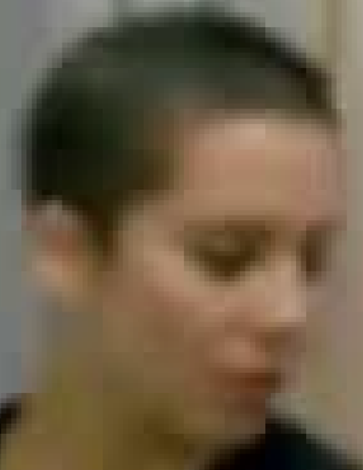
Original CRF28 CRFf35
Figure 1: The visual appearance of the same image varies under different compression rates; while the differences resulting from these varying rates are not readily apparent in the visual images themselves, they become distinctly evident in spectral analyses—specifically those utilizing FFT and DCT—particularly within the high-frequency and spectral structure regions.
All images were uniformly resized to a resolution of 224×224 pixels and normalized using standard ImageNet statistical parameters. For frequency-domain analysis, we transformed the images into their corresponding spectral representations using either the Fourier Transform or the Discrete Cosine Transform (DCT).
To further probe the extent of the model's reliance on frequency-domain features, we employed a "frequency-domain masking" technique during the training process, conducting experiments by selectively suppressing specific frequency bands.
3.3 Frequency Analysis
For frequency analysis, we randomly sample 150 images from each subset and resize them to 256×256 grayscale images. Pixel values are normalized to [0,1].
We apply both Fast Fourier Transform (FFT) and Discrete Cosine Transform (DCT) to analyze frequency characteristics. For FFT, we compute the log magnitude spectrum after applying fftshift to center low-frequency components see Figure 2. For DCT, we use 2D orthogonal DCT and similarly apply log scaling see Figure 3.

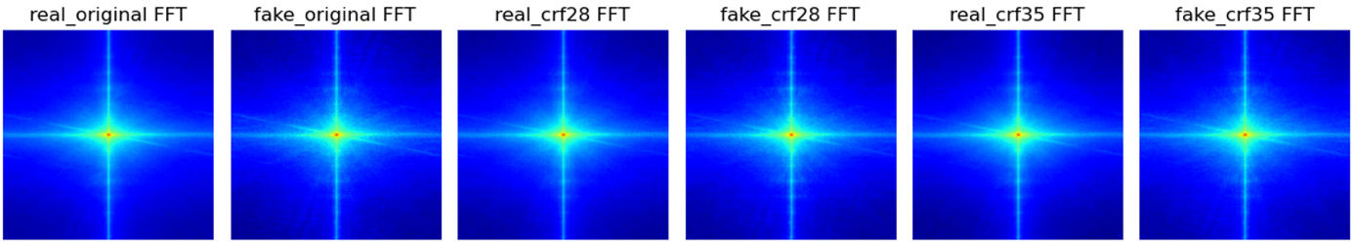
Figure 2: Within the two bright lines of the cross—representing the lateral and vertical variations in frequency response—we observe that the crosshairs of the "fake" images, at a given compression ratio, exhibit a more pronounced grid pattern than those of the "real" images. Concurrently, in the high-frequency region (depicted in dark blue), we can also discern subtle color discrepancies between the fake and real images at the same compression ratio; this indicates a difference in high-frequency intensity.
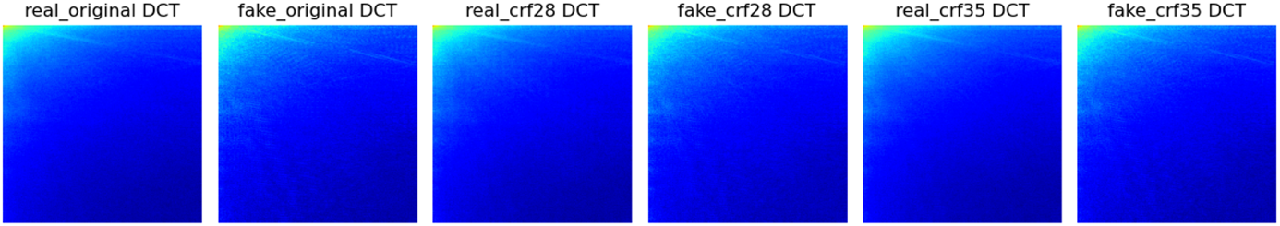
Figure 3: In the DCT spectrum, the differences between real and fake samples are not particularly pronounced in the high-frequency range; however, in a comparative analysis across varying compression rates, we observed an increase in noise levels corresponding to the rise in compression rate.
3.4 Model Training
We adopt ResNet-18 as the backbone network for deepfake detection. The model is initialized with ImageNet-pretrained weights and fully fine-tuned for the binary classification task (real vs. fake). The final fully connected layer is replaced with a two-class output layer.
Training is conducted on a mixed dataset composed of frames extracted from videos under three compression settings: original, CRF28, and CRF35. All training subsets are combined to improve the model’s robustness to compression-induced variations. In addition, a baseline setting is established by training and testing the model on the original (uncompressed) dataset only.
During training, standard data augmentation techniques are applied, including resizing to 256×256, random resized cropping to 224×224, horizontal flipping, and brightness and contrast adjustments. All images are normalized using ImageNet mean and standard deviation.
The model is trained for 40 epochs using the Adam optimizer with a learning rate of 1e-4 and a batch size of 32. Cross-entropy loss is employed as the objective function. All parameters of the network are updated during training.
For evaluation, the model is tested under different compression conditions using separate or mixed test sets. Performance is assessed using Accuracy, Precision, Recall, F1-score, and the confusion matrix to provide a comprehensive evaluation of classification performance. This setup enables a direct comparison between single-domain training, mixed-domain training, and the baseline, thereby facilitating the analysis of domain shift effects.
4. Experimental Results
We first established a baseline by training and testing the model on the original (uncompressed) dataset. Under this configuration, the model achieved an accuracy of 74.6% and an F1 score of 80.63%, demonstrating that the model performs well in the "original-to-original" scenario. The results for the other models we trained are as follows see Figure 4:
Train\Test | original | crf28 | crf35 | mixed
original | 0.746 | 0.746 | 0.7367 | 0.7429
crf28 | 0.7136 | 0.7159 | 0.7206 | 0.7167
crf35 | 0.6628 | 0.6651 | 0.6813 | 0.6697
mixed | 0.8868 | 0.8799 | 0.873 | 0.8799
Figure 4: The accuracy rates obtained from models with varying compression ratios, tested on corresponding test sets.
We first observe that models trained and tested on the same compression level (diagonal entries) generally achieve relatively higher performance compared to cross-compression settings. For example, the model trained on CRF28 achieves 0.7159 when tested on CRF28, but its performance drops to 0.7136 and 0.7206 when tested on original and CRF35, respectively. A more significant degradation can be observed for the CRF35-trained model, where the accuracy decreases from 0.6813 (same-domain) to 0.6628 when evaluated on the original dataset.
This trend becomes more evident when examining models trained on higher-quality data (original). Although the model trained on original data achieves 0.746 accuracy on its own domain, its performance decreases when tested on compressed data, particularly CRF35 (0.7367). This indicates that the model fails to generalize well across different compression levels.
In contrast, the mixed-trained model demonstrates consistently strong performance across all test domains, achieving 0.8868, 0.8799, and 0.873 on original, CRF28, and CRF35, respectively. More importantly, the performance gap across different domains is significantly reduced compared to single-domain training.
These results suggest that the performance degradation observed in cross-compression settings is not primarily caused by the loss of discriminative information, but rather by the distribution mismatch between training and testing data. The effectiveness of mixed training further confirms that exposing the model to multiple compression domains enables it to learn more robust and invariant features.
Therefore, we conclude that the observed performance variation across compression levels is mainly attributed to domain shift rather than intrinsic feature loss.
5. Frequency Analysis Results
To better understand whether the impact of image compression on frequency-domain characteristics corresponds to domain shift rather than a simple change in signal strength, we conduct a detailed frequency analysis.
Specifically, we compute the FFT radial energy profiles for both real and fake images under different compression levels, which allows us to quantify how frequency distributions vary across domains see Figure 5. In addition, we compare the FFT spectra of images from the same class (real or fake) under different compression settings to visualize the changes in frequency components see Figure 6.
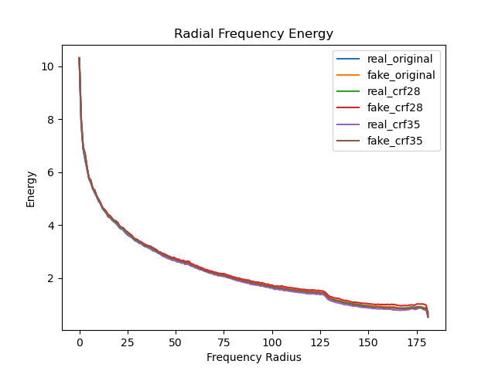
Figure 5: The FFT radial energy of different classes and compression levels.
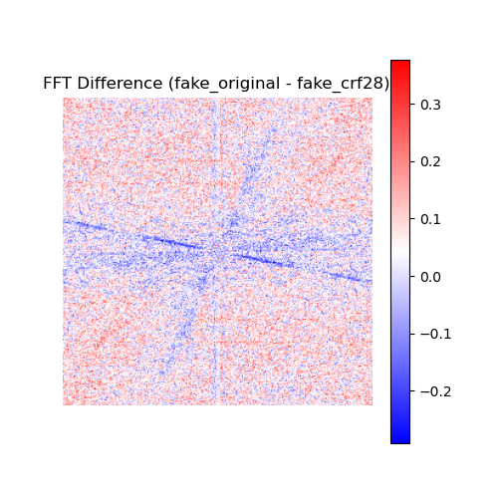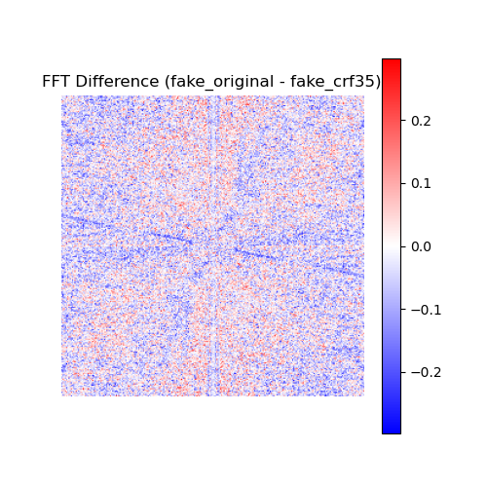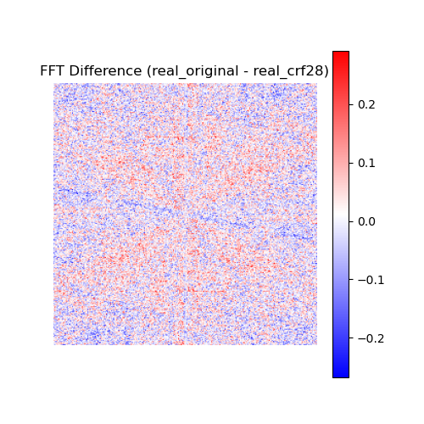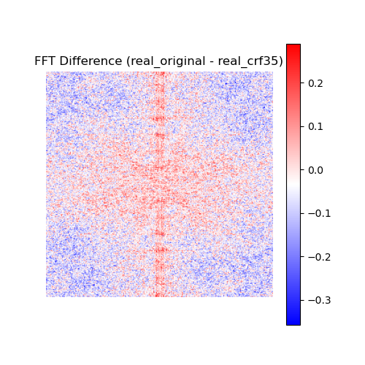
Figure 6: FFT spectra of images from the same class (real or fake) under different compression settings, A negative value indicates that the intensity of the corresponding frequency has decreased compared to its level prior to compression, while a positive value indicates the opposite.
From Figure 5, it can be observed that the radial frequency energy curves of all six groups are highly similar, with only minor deviations appearing in the high-frequency region. This indicates that image compression does not significantly alter the overall magnitude of frequency components.
Therefore, the degradation in model performance across different compression levels is unlikely to be caused by a simple loss of high-frequency information. Instead, it suggests that compression primarily affects the distribution of frequency components.
Figure 6 further supports this observation. By comparing the FFT spectra before and after compression within the same class, we observe distinct structured patterns along the horizontal and vertical axes (i.e., cross-shaped structures centered in the frequency domain). These patterns are fundamentally different from the scattered, noise-like variations observed in other regions.
The scattered “snowflake-like” patterns are more likely to be compression-induced noise, whereas the structured cross patterns indicate systematic changes in frequency components along specific directions. This implies that compression introduces directional redistribution of frequency energy rather than uniform attenuation.
Such structured changes reflect a shift in the underlying frequency distribution, which can be interpreted as domain shift rather than a simple change in signal strength.
6. Discussion
The experimental results and frequency-domain analysis consistently indicate that the degradation in model performance across different compression levels is primarily caused by domain shift rather than a simple loss of frequency information.
From the FFT radial analysis, we observe that the overall magnitude of frequency components remains largely stable across compression levels, with only minor differences in high-frequency regions. This suggests that compression does not significantly eliminate discriminative information. However, the FFT difference maps reveal structured, directional changes—particularly along horizontal and vertical axes—indicating that compression alters how frequency components are distributed rather than their absolute strength.
These findings imply that deepfake detection models may implicitly rely on domain-specific frequency patterns during training. When the distribution of these patterns shifts due to compression, the learned representations become less effective, leading to performance degradation. This explains why models trained on a single compression level fail to generalize well across others.
Furthermore, the strong performance of the mixed-training model supports this interpretation. By exposing the model to multiple compression domains during training, it learns more robust and domain-invariant features, significantly reducing the performance gap across different test settings. This provides empirical evidence that domain shift, rather than information loss, is the dominant factor affecting model generalization in compressed deepfake detection scenarios.
7. Future Work
Although this work provides evidence that compression-induced performance degradation is largely driven by domain shift, several directions remain for further improvement.
First, future work could explore frequency masking strategies to enhance model robustness. By selectively suppressing or perturbing certain frequency bands during training, the model may be encouraged to rely less on domain-specific frequency artifacts and instead focus on more generalizable features. This could further mitigate the impact of compression-induced distribution shifts.
Second, this study focuses on frame-level image analysis, which does not fully exploit the temporal information available in videos. Incorporating temporal consistency modeling, such as through recurrent networks or temporal attention mechanisms, may significantly improve detection performance in real-world scenarios. Deepfake artifacts often exhibit temporal inconsistencies across frames, and leveraging this information could provide an additional robust signal beyond spatial and frequency-domain features.
Finally, extending the analysis to more diverse datasets and real-world compression pipelines would help validate the generality of the proposed findings and further strengthen the applicability of domain shift-aware approaches in practical settings.
8. Conclusion
In this work, we investigate the impact of image compression on deepfake detection from a frequency-domain perspective. Through systematic experiments across multiple compression levels and detailed FFT-based analysis, we demonstrate that compression does not significantly reduce the magnitude of frequency information, but instead alters its distribution.
Our results show that models trained on a single compression level suffer from notable performance degradation when evaluated on other compression domains. In contrast, mixed training across multiple compression settings significantly improves generalization, indicating that the underlying issue is domain shift rather than information loss.
The frequency analysis further supports this conclusion by revealing structured changes in frequency distributions, particularly along specific directions, which are not captured by traditional magnitude-based interpretations. These findings highlight the importance of considering distributional changes in frequency space when designing robust deepfake detection models.
Overall, this work provides both empirical and analytical evidence that addressing domain shift is critical for improving the robustness of deepfake detection systems under compression, and offers insights for future research in frequency-aware and domain-invariant model design.
9. Reference
[1] R. Tolosana, R. Vera-Rodriguez, J. Fierrez, A. Morales, and J. Ortega-Garcia, “Deepfakes and beyond: A Survey of face manipulation and fake detection,” Inf. Fusion, vol. 64, pp. 131–148, Dec. 2020, doi: 10.1016/j.inffus.2020.06.014.
[2] J. Frank, T. Eisenhofer, L. Schönherr, A. Fischer, D. Kolossa, and T. Holz, “Leveraging Frequency Analysis for Deep Fake Image Recognition,” Jun. 26, 2020, arXiv: arXiv:2003.08685. doi: 10.48550/arXiv.2003.08685.
[3] C. T. C. Doloriel, H. Ullah, K. H. Liland, F. A. Machot, and N.-M. Cheung, “Towards Sustainable Universal Deepfake Detection with Frequency-Domain Masking,” Feb. 03, 2026, arXiv: arXiv:2512.08042. doi: 10.48550/arXiv.2512.08042.
[4] Y. Jeong, D. Kim, Y. Ro, and J. Choi, “FrePGAN: Robust Deepfake Detection Using Frequency-level Perturbations,” Feb. 07, 2022, arXiv: arXiv:2202.03347. doi: 10.48550/arXiv.2202.03347.
[5] S.-Y. Wang, O. Wang, R. Zhang, A. Owens, and A. A. Efros, “CNN-Generated Images Are Surprisingly Easy to Spot... for Now,” presented at the Proceedings of the IEEE/CVF Conference on Computer Vision and Pattern Recognition, 2020, pp. 8695–8704. Accessed: Mar. 27, 2026. [Online]. Available: https://openaccess.thecvf.com/content_CVPR_2020/html/Wang_CNN-Generated_Images_Are_Surprisingly_Easy_to_Spot..._for_Now_CVPR_2020_paper.html
[6] A. Rossler, D. Cozzolino, L. Verdoliva, C. Riess, J. Thies, and M. Niessner, “FaceForensics++: Learning to Detect Manipulated Facial Images,” in 2019 IEEE/CVF International Conference on Computer Vision (ICCV), Seoul, Korea (South): IEEE, Oct. 2019, pp. 1–11. doi: 10.1109/ICCV.2019.00009.
[7] D. Afchar, V. Nozick, J. Yamagishi, and I. Echizen, “MesoNet: a Compact Facial Video Forgery Detection Network,” in 2018 IEEE International Workshop on Information Forensics and Security (WIFS), Dec. 2018, pp. 1–7. doi: 10.1109/WIFS.2018.8630761.
[8] H. Liu et al., “Spatial-Phase Shallow Learning: Rethinking Face Forgery Detection in Frequency Domain,” Mar. 10, 2021, arXiv: arXiv:2103.01856. doi: 10.48550/arXiv.2103.01856.
[9] Y. Qian, G. Yin, L. Sheng, Z. Chen, and J. Shao, “Thinking in Frequency: Face Forgery Detection by Mining Frequency-aware Clues,” Oct. 27, 2020, arXiv: arXiv:2007.09355. doi: 10.48550/arXiv.2007.09355.
[10] G. Csurka, “Domain Adaptation for Visual Applications: A Comprehensive Survey”.
[11] Y. Li and S. Lyu, “Exposing DeepFake Videos By Detecting Face Warping Artifacts,” May 22, 2019, arXiv: arXiv:1811.00656. doi: 10.48550/arXiv.1811.00656.

